What we talked about:
- Don’t forget to go look at the tutorials/send me your github usernames
- Overview of the story, see 10-1 game design document, specifically the narrative and gameplay sections.
- Brainstormed gameplay features
- Brainstormed lore
- We’ll be switching to communicating with teams soon
- I’d like to do weekly meetings until school starts. I'll send out the time of the next one tomorrow.
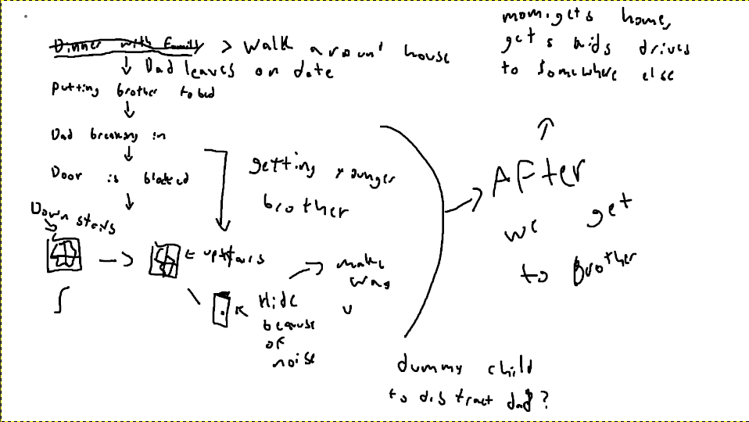
^drew this while brainstorming what comes next
Current plan for the the game:
1) Implicit Tutorial Section (the less words the better)
- The game will start earlier than we originally thought, giving the player time to walk around, talk to family members, and play minigames that explain how the game will work.
- Some suggested minigames: hide and seek - explains hiding mechanic, baseball - explains how to hit things/pick up items
- Discussed possibly making this first section last several days, I think we could probably just have it take place earlier in the day and not have to create multiple days worth of stuff to do.
2) Parents leave on date
- Micheal takes Gus to bed on one of the upper floors, Micheal goes to his room in the basement
- Time to explore house alone before bed
- Player goes to Michael's room when ready for next section
3) Dad breaks in upstairs (Finding Gus)
- This starts the meat of the Game, where Michael's goal for this first section is to find his brother in order to protect him.
- The player will likely check the door first, finding it to be blocked and making him find another way to get upstairs
- Somewhere in the basement there will be a crowbar, the first “ability”
- Player will have to break a window to get out of the basement, and get access to the rest of the house by climbing into the window already broken by dad
4) Whatever happens next
- This was the sort of “homework” I gave everyone, just to be thinking about what comes next in the story
- What the story will ultimately be leading to is the kids making it to safety somehow. Some Ideas for how that will happen are:
- The kids have to make their way to an ipad or something that has the ability to contact the police or mother, who then come to rescue them
- The kids just have to find a flare to send out and alert the military rounding up survivors
- Ideas for what comes next should be within the context of them finding new items that open up new access to different areas of the house.
- One suggestion I have is to focus on coming up with items that add new fun abilities, and think of ways they can lead to unlocking new sections of the house.

Notes about gameplay:
The gameplay will focus on finding items that give you new abilities, and access to more areas of the house. It will be a similar style of progression to metroidvania type games, but in the top down style. The items should ideally allow for new interesting abilities/moves gameplay-wise and not just be a key that does nothing but open access.
Crowbar: ability to break windows, stun dad
Climbing shoes: ability to climb up the laundry shute (we didn’t talk about this in the meeting)
It might also be interesting to have the kid only be able to hold a few big items like the crowbar at a time, and set them down otherwise. Then you’d have to remember where you put it, and make your way there while avoiding the dad when you need to use it. (a little “key” like)
Lock pick: opening locked doors (also a little “key” like)

We also talked about lore:
- Consciousness in this world is granted by an eldritch being within the moon. The moon isn’t necessarily important, i just thought it would lead to cool imagery like the tides becoming less strong, and the moon getting smaller in the sky
- The “disease” is taking place because this being is leaving, and therefore taking the consciousness it grants away as well.
- This deity isn’t even necessarily aware that it has this effect on humanity, it could be as simple as it fell asleep within the earth's orbit for a few 100’s of thousands of years, woke up and is just going away back to its normal eldritch activities.
- ^ For this point conner suggested it COULD actually be aware of humanity, and angry that people aren’t paying attention to the moon anymore, what with phones and such. Then it chooses the more blatant offenders to take away their consciousness as punishment for forgetting about him. That would explain why it affects some people more than others
- Humanity is completely unaware of this deity, and thinks that it is a disease or some other cause. Nobody really is aware of what is actually happening. Maybe a few conspiracy groups or something. Maybe the mom is part of one of these groups, and we find her notes spread around the house
- (this wasn’t discussed in the meeting, just me spitballin) maybe the mother is part of a cult type group that thinks the deity works in the way conner was describing, but in reality it's just indifferent to humanity. That could be why the dad went home without her, he went crazy on the date, and she left him to try and figure out how to stop it not realizing he would make his way back home to the kids
One big thing we talked about is why the dad is affected and the kids aren’t. It can’t be just because of distance or everyone would be feeling it the same. One thing i was thinking would be the son has a necklace with moon dust or something, thus bringing him closer to a part of the deity.

Anything I missed? (write it below)

